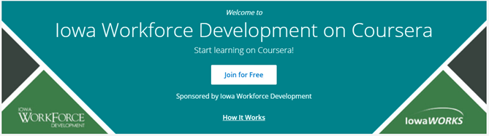

**Iowa Workforce Development has partnered with Coursera to offer FREE online learning opportunities, courses, and certificate programs to Iowans during the pandemic. Registration and course enrollment are open through September 30, 2020. After enrollment, you will be able to complete courses at no cost through December 31, 2020. Request your Invitation** [**HERE**](https://docs.google.com/forms/d/e/1FAIpQLSeB9m0xubytHnnisplfQZNVfOLv1t-Kg556r14iJITgNUP9qw/viewform)**!**

**Google Form URL for Request of Invitation:**

<https://docs.google.com/forms/d/e/1FAIpQLSeB9m0xubytHnnisplfQZNVfOLv1t-Kg556r14iJITgNUP9qw/viewform>

Example Tag Lines for Emails:

Access FREE online courses with Iowa Workforce Development and Coursera. Register and enroll in courses by September 30, 2020 and complete those courses by December 31, 2020 at no cost to you. Request your Invitation [HERE](https://docs.google.com/forms/d/e/1FAIpQLSeB9m0xubytHnnisplfQZNVfOLv1t-Kg556r14iJITgNUP9qw/viewform)!

FREE online courses and certificate programs with Iowa Workforce Development and Coursera. Register and enroll in courses by September 30, 2020 and complete those courses by December 31, 2020 at no cost to you. Request your Invitation [HERE](https://docs.google.com/forms/d/e/1FAIpQLSeB9m0xubytHnnisplfQZNVfOLv1t-Kg556r14iJITgNUP9qw/viewform)!